Economic Growth, Individual Rights and Social Ties:
Challenges Confronting Modern India

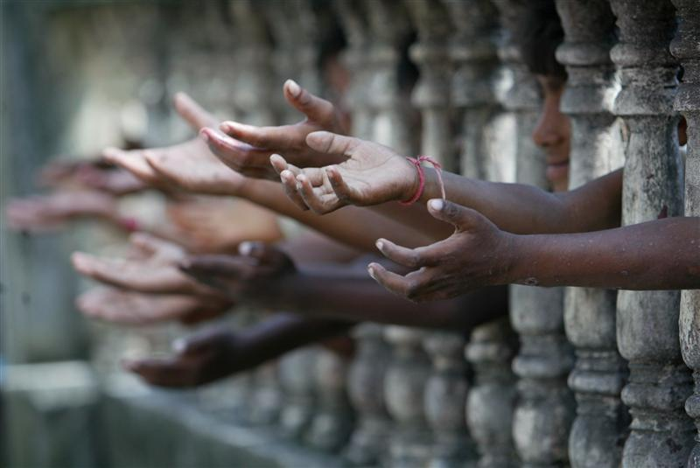

Profile Project
Sara de Jong
Economics (NT)
Rijnlands Lyceum Oegstgeest, V6D
Tiddo Redingius
15-12-2014

Abstract

India is a country with many contradictions; while it is known for its insane economic growth, the other vision people get when thinking about the South Asian country, is that of extremely malnourished children and poverty. India is a country with an extremely complex society, possibly the cause of these contradictions. The question is how do the economic growth, these social ties and the individual rights relate? Two Indian born economists have completely different views on this interrelationship. By comparing the theories of these economists and the actual numbers provided by databanks, it became visible that India is a country with such a high level of complexity, which makes it unable to ‘frame’ according to either one simple theory of economic growth, or one big social experiment. The role of the government is crucial in this interrelationship, the gap between rich and poor is a growing one, that will keep growing without intervention of the government. The question of what came first, economic growth or social development is similar to the chicken-or-egg discussion, the numbers are not able to answer this question. The theories given by world’s most famous economists, designed for countries with a lower level social complexity, do not fit India. It is the government that must aim to relieve the poverty among the lives of the people in India, not in the hope of creating more economic growth, but simply because it cannot continue to fail half of its citizens.

Contents

Introduction

Chapter 1: India After Independence
  - A New Economy for a New State: the Economic Development of India 1947-now
- Inheriting a colonial economy
  - Economic Development
- The first 45 years after independence
- India with a free market economy
  - Social Structure: The Caste-System
  - Communalism and Legal Pluralism
- Language and language policies
- Political, social and cultural communities
- Religious differences
- What does this mean?

Chapter 2: Economy, Law and Society in the work of Jagdish Bhagwati and Amartya Sen

2.1 Standard Theories of Economic Growth
a. Ragnar Nurske
b. Keynes & Harrod-Domar
c. Jagdish Bhagwati and Arvind Panagariya

2.2 Amartya Sen

Chapter 3: Number Crunching: Economic Indicators of India’s Performance
3.1 Women in the Modern Indian Society
3.2 Health in Modern India
a. Child Mortality
b. Maternal Health
c. Health Expenditure
3.3 Education and Literacy
a. Literacy
b. Education

Chapter 4: Conclusion: Economic Growth and Social Justice

Introduction

When most people in the West think of India, they usually come up with one of two completely different images. The first is that of economic activity: sweatshops where our clothes are made in appalling conditions, European companies which outsource many of their services to India, the Tata and Mittal companies taking over the world of steel manufacturing, etc. The second image is that of poverty: in spite of its economic activity, it seems, India cannot provide for its own (booming) population. It ranks very high on many of the lists of problems, in the areas of health, sanitation, gender equality, etc., and very low on indicators of well-being. These images, that of India as a booming economy with fabulous wealth and limitless opportunities, and that of India as a country of child labour, deepest poverty, and lack of sanitation, are both true. These are realities that coincide, living alongside each other the way various groups and classes of people have lived alongside each other in India for thousands of years. The question is how they are related. To summarize the question is: “What is the relation between economic growth, individual rights and social development in India?”
I have witnessed very similar problems when I did my international internship in Nepal last year. My friend Anne Sophie and I worked for two weeks in an orphanage and a primary school in Kathmandu, in a neighbourhood with the telling name of Pepsicola. We have seen poverty there, but we have also seen progress. I have been thinking about the question how poverty can endure in times of economic growth ever since.
The case of India is more extreme than that of Nepal. Not only is India much bigger, it is also far more complex, on almost every level. Extreme cases are, of course, difficult, but they also help with difficult questions. What I want to know for this project is how economic growth relates to individual rights and social justice. Because India has so many problems in these areas, it is – I think – a good country to work on. There are two opposing perspectives I am going to use: the first is the more classical one, that claims that economic growth is a necessary condition for increasing equality and justice. The second one is its opposite: it claims that social justice is a necessary condition for sustainable economic growth. I discuss these positions in the works of two Indian economists: Jagdish Bhagwati as representative of the former perspective, and Amartya Sen as main spokesperson of the latter.
This report is structured as follows; first I’m going to explain the complex situation in India, which is necessary to understand to a certain extend, since it is one of the causes of the problems in India. This will be divided up into three ‘areas’ of the Indian society: economic development, social structure and communalism and legal pluralism. Secondly I will introduce the two mentioned Indian economists, both with a completely different view on the interrelationship between social ties and economic growth. Chapter three will present numbers and figures, which show the social development in Modern India. In chapter four a conclusion and summary of this profile project will be presented.
Chapter 1
India After Independence

India became independent from Britain on August 15, 1947. The years immediately before independence had been years of violent and non-violent resistance to the inclusion of India in Britain’s colonial empire. The ‘India’ that was to come into being, however, would not take the territorial form in which it had existed as part of the British Empire. Mahatma Gandhi, the leader of the Indian independence movement, envisioned a unified India, in which religious and social differences would be brought together. But this was not meant to be: during the negotiations for India’s independence it became clear that those parts of the country that were inhabited by Muslim majorities would build their own, Muslim-majority state. India was thus be partitioned, and Pakistan – a country in two parts: the modern republic of Pakistan and the modern republic of Bangladesh – came into being together with India.
Both countries-to-be, India and Pakistan, had – in their colonial times – included a large number of so-called ‘princely states’, which were part of the empire, but nominally autonomous, ruled for the British by local princes. These princely territories were in principle free to join either Pakistan or India. The choices made by them were largely predictable, except in the case of the large princedom of Jammu and Kashmir, which chose to join India in spite of the fact that it had a majority Muslim population. Kashmir has been the cause of the war between India and Pakistan ever since.
Partition was a painful process that led to a lot of rioting and especially to large-scale population transfers between the two countries: many Muslims left India for Pakistan (although many also remained in India), and almost all Hindus left Pakistan for India. There were, however, deeper wounds for India soon to be struck. On January 30, 1948, Mahatma Gandhi was assassinated by a Hindu nationalist. Although Gandhi was not part of the political establishment – he had been a fierce opponent of partition – the fact that he was murdered caused the young state enormous grief and a potentially unstable situation.
Political power was held, chiefly, by Gandhi’s close friend Jawaharlal Nehru, the architect of modern India. It is clear that he did not, could not in fact, inherit a familiar political situation: before his leadership, the government of India was in the hands of the British occupants. It is important for this project to realize what he did inherit, however, and how he changed this inheritance, and in which ways he attempted to build a new state. We will discuss these questions of ‘inheritance’ and development under three rubrics: economy, social structure (the ‘caste-system’), and communalism and legal pluralism, since these three are crucial for a proper understanding of the challenges of modern India.

  - A New Economy for a New State: the Economic Development of India, 1947-now

The first section will focus on the economic development of India since independence. We will focus, first, on the question of the ‘inherited’ economy and the economic prospects of the young state; then, we will discuss the period of guided economy (in the shape of socialist-style five-year plans), and finally the more recent developments after the momentous change in economic policy towards a liberal economic model.

- Inheriting a colonial economy

Colonial empires are odd economic structures. They are, essentially, territories that are supposed to be economically productive for others than the inhabitants of their own country. The reality of the colonial economy of India has been well described by Angus Maddison, in chapter 3 of his book Class Structure and Economic Growth: India and Pakistan since the Moghuls (1971), which is called ‘The Economic and Social Impact of Colonial Rule in India’. Maddison notes, first, that the British (like the Dutch, and unlike the French, Spanish and Portuguese) did not have missionary or cultural intentions in the building of their colonial empires, but only economic and strategic ones. They came to India (in the shape of the East India Company) not to bring something there, but to gain something from it. First, this gain was seen especially in terms of trading privileges or monopolies: the East India Company slowly, but unstoppably, pushed out the Dutch and French colonial presence in India. With the rise of industrialization in Britain, India came to be seen not only as a source of raw materials, but also as a huge market for English goods. Controlling India was, of course, also a source of considerable political, military and strategic power. These conditions implied that the chief economic efforts of the British in India were to be limited to strategies of pacification (keeping the people quiet) and economic extraction. As a result, there was to be hardly any industrialization of India, and not much economic growth. India, in fact, transformed into a largely agriculture-based economy, and as a consequence had a very low rate of economic growth – barely one percent (keeping up with population growth), and sometimes even periods of stagnation. To quote Angus Maddison:

“There has been a good deal of controversy amongst statisticians about the rate of growth of income in India in the colonial period. The argument is politically coloured and the statistics are poor. For the last fifty years of British rule there is enough statistical information to make rough estimates of the growth of national income. My own estimates […] show no increase in per capita income over the years 1900-46.”

This is, of course, a devastating verdict – and it must have been a daunting task for India’s new government to think of a strategy that would show India a way out of its economic stagnation – although it seems thus to be the case that any strategy chosen would by definition have outperformed the British handling of India’s economic development. Any plans to change the downward trend, however, were overshadowed by a war that broke out with Pakistan almost immediately after independence. As mentioned above, the cause of this war was the accession of the princely state of Jammu and Kashmir to the republic of India, in spite of its clear Muslim majority and local expectations that it would join Pakistan. The war lasted until December 1948, and must have overshadowed many of the other difficulties the new government faced.
Some of these were economic, but many more were social (these will be discussed separately in this chapter). Initial economic policy seemed to rely very much on economic interventionism that aimed at improving social, rather than economic, conditions. Having experienced the extractive logic of a (liberal) colonial economy, and being aware of the huge social difficulties India as a state faced, it is no miracle that the early politicians did not look to the liberal economies of Western Europe for economic (or social) inspiration, but decided to rely (more or less) on the example of the socialist experiments of the Soviet Union (a state much bigger than India, but similarly complex).

  - Economic Development

In order to understand the economic growth of India it is important to separate its economic history into two phases: an interventionist one in the first 45 years after independence and a more liberal one, approaching the model of a free market economy, since 1991.

- The first 45 years after Independence

After independence India decided to grow as a planned economy. A planned economy is an economic system in which the government is in full control of decision-making when it comes to economic decisions dealing for example with production, pricing, distribution and investment. India divided its economy into two segments: the private sector and the public sector. The private sector operated small to medium size businesses and the industries protected by the government (the public sector) took care of everything else. The public sector started off the economic growth in India. Jawaharlal Nehru, the first Indian prime minister, presented the First Five-Year Plan to the Parliament of India in 1951. This mainly focussed on development in the primary sector, which makes direct use of natural resources, such as agriculture and mining. This first Five-Year Plan, which launched the growing economy of India, was based on the Harrod-Domar model of economic growth. This model focuses on the quantity of labour and capital and measures economic growth by comparing the level of savings and the capital output ratio. If a country has a high level of saving, it can provide funds for firms that will then borrow and invest with the goal of eventually growing bigger. The capital output ratio (amount of capital needed to produce one unit of output) measures the productivity of the money that is invested into, for example, new machines. This implies that when this ratio decreases, higher amounts are produced but with less input needed. A basic formula explaining the model is:

Rate of growth = Savings / capital output ratio

This model is mainly used in developing economies, like that of India at the time, and in brief is focussed on decreasing the capital output ratio in an economy.
Not all of the five-year plans worked. Sometimes, severe droughts or periods of very heavy rainfall intervened, harvests were ruined, and famine arose. At other times, historical circumstances were bad. In 1962, for example, India went to war with China. In 1965, there was another war with Pakistan, which caused the actual growth to differ almost 3% from the target growth. In 1979, the five-year schedule completely failed. There were two Sixth Plans. The first was put forward by the Janata Government, which was supposed to be followed from 1978-1983, but the government itself only lasted for two years and the new government (which brought Indira Gandhi back in power) implemented a new Five-Year plan for the upcoming five years (1980-1985). Both plans, but especially the Janata government one (the “Rolling Plan” featuring a protectionist agenda that was rare even for India at the time) were total failures. This governmental failure hugely affected the GDP Growth Rate as visible in Chart 1:
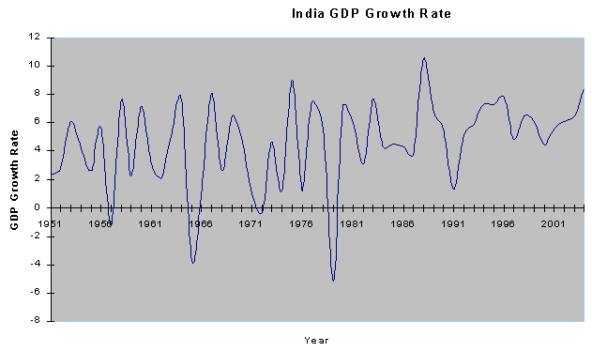
Graph 1 India GDP Growth Rate

Ever since the First Five-Year Plan, India has witnessed a changing composition of its economic structure. Agriculture became less important and declined from 60% of the GDP to now comprising about 26%. Services now comprise 75% of the GDP, up from 30% in 1940-1950. Industry, the third tire of the system (in the percentages part of the services), was slower to develop. It is this slow development of Indian industry, which may explain the current over-representation of the services sector, which continues to make India’s economy look fragile. Any progress made in India during this period was extremely slow due to India’s complicated democratic, political, and social system. Its economic policy was interventionist, protectionist and almost fully controlled by the (frequently instable, and rapidly expanding) various levels of government. This fact is often reduced to a problem of ‘corruption’ – but we need a full discussion of the social structure of India to understand how this corruption is produced (and it may not be identical with other examples of ‘corrupt’ government officials in countries like Italy, Colombia, or Indonesia). In economic retrospect, the period of the five-year plans was more or less a disaster, preventing India from growing the way it could have grown, had it adopted different economic policies. On the other hand, much progress was made in the many highly complex social problems that characterized newly independent India. And these social problems, this project report will argue, have a real economic impact, too.

- India with a free market economy

Everything changed in 1991. The world had, of course, changed in 1991: the Soviet Union, India’s role model and certainly its biggest trading partner, had collapsed. The economy of India could barely cope with these changes. After a deep and painful fiscal crisis in 1991, India started to adopt free-market principles and liberalised its economy to international trade (under pressure, it must be noted, of the IMF). A free market economy means that the government does not interfere in business activity in any way. Prices are based on competition among private businesses and are not controlled by the government (free price system). This is, however, a theoretical concept since every country controls and restricts the exchange of certain products. In India this meant a drastic decline in the intrusion of the government in the economy of the country. Besides this interest in foreign investment grew. The government gave the private entrepreneurs liberties they had never had before. As a result, the Indian economy showed patterns of growth that had never been reached before. The GDP occasionally had double-digit yearly growth figures (10 % in 2007 and 2010, respectively), and an average yearly growth of 7.4 % between 2005 and 2013.
This is generally presented as a success story, and successive Indian governments have certainly presented it in these terms. At the same time, India also dominates most of the world’s lists of indicators of social and economic problems: lists that estimate the distribution of wealth, for example, or real poverty, access to health care, literacy, gender equality, corruption, etc. Is this the dark side of India’s economic growth? Did that growth arise on the basis of the suffering of hundreds of millions who do not enjoy its benefits? Or is it the other way around: does the hope for a better future glimmer for those Indians, too, as long as economic growth continues to dominate India’s future? It is these questions this project report aims to investigate. It will do so by opposing ‘classical’ economic theory to the insights of the Nobel laureate Amartya Sen. Before we come to these economic matters, it is important to present the very real social problems India faces.

  - Social Structure: The caste-system

It is a bit of an understatement to say that Indian society is very complex. India is a country with many diverse peoples and cultures. Customs and traditions vary from region to region. It is a country with numerous different languages, a divide in different religions and a difference of social classes between numerous groups of the population. However some unity has been achieved for this dazzling variety in its social structure, which can be seen as a ‘unifying force’.
This social structure is based on the caste system. A caste is “A social class separated from others by distinctions of hereditary rank, profession, rank or wealth” . This means that there are different groups in the society of India, which are related in a hierarchical way to each other. Each group has a different rank in society and therefore has different possibilities in life. In India these groups are called “jatis” (literally: “births”). There are thousands of jatis in India, each with different characteristics and customs. All these jatis are arranged in hierarchical order and have been summarised into four “varnas” (which is Sanskrit for “colours”). All people in the same varna have the same rights and duties, language, customs, food habits and dress the same way. They are all born in the caste they belong to. It is not possible to get to a caste that is of higher rank, nor is there a way to get to a caste that is of lower rank, in short they were prevented from aspiring to climb higher and you could say that that restricted economic progress.
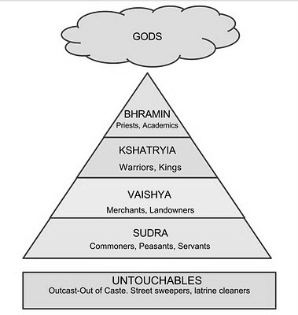
As can be seen on the left diagram (1) the lowest class of the hierarchy are called the Sudra. The Sudra are the poorest people of India. They are mainly unskilled labourers and servants. One step higher are the Vaishya; these are mainly the farmers, traders and artisans. Moreover they engage in commercial activity as businessmen. Above them are the Kshatriya, who provide public services, such as administration and maintenance of law and order, and defence. The top layer of this social structure is formed by the Brahmins, traditionally priests, but also scholars and, later, politicians. Finally, at the bottom of the whole system – or actually, outside the system itself – are the “untouchables”, or “outcastes”, who generally used to work in a jobs such as cleaning streets and houses, and who were (and still are) shunned by those of higher caste-birth. The untouchables (pariahs) were renamed “Harijan” (‘children of God’) by Gandhi; nowadays, they are mainly referred to as Dalits (from a Sanskrit word meaning ‘crushed’). In official usage, they are also referred to as “scheduled castes”.
Diagram 1 Hierarchical Order Caste-System Modern India

Within the caste-system itself, a distinction is made between the “twice-born” castes (who are born both in a physical and in a spiritual incarnation), which make up the upper three varnas, and the Shudra (and Dalit) castes, who are believed to be polluting to the higher castes. All kinds of regulations were in place (and are maintained locally to the present) that would ensure that the lower castes could not come too close to the higher castes, and thus pollute them. Although untouchability was officially made illegal in India as early as the 1950s, and the caste system has been declared irrelevant by many modern politicians, it is widely agreed that the social structure enshrined in the caste system is still largely in place in India.

The injustice that outsiders to the system immediately point at in this system – which distributes social (and often also financial) status on the exclusive basis of peoples’ births – is currently recognized by many Indians, too, although the system itself continues to operate largely as before. It is carried by the religious traditions of India: anyone can climb the social ladder according to Indian beliefs, but only in the next life. Indians believe in an almost endless cycle of rebirths through a series of different incarnations, which are especially conditioned by the duty to do (in religious and moral terms) exactly what your current birth and stage of life requires you to do. This is called the varnashramadharma (‘the law of caste and stage-of-life’) system and it remains largely uncontested in large parts of India.

What all of this means for India’s economy is more difficult to estimate, but this matter will be discussed after we have given an overview of the other crucially important factor of Indian society to be discussed: communalism.

  - Communalism and Legal Pluralism

Alongside the issue of poverty and the unequal distribution of wealth and economic growth, and problems caused by the traditional Indian social structure, there is one final aspect to be discussed for a proper understanding of the interrelation of economic growth and social justice in India. This is the question of communalism, which exists alongside (or as part of) the caste-based social patterns of organization in India. The complexity of India as a nation has been highlighted several times already. It shows itself in various different domains of Indian society: linguistic, political, cultural, social, religious. The latter domain is by far the most explosive. In order to deal with the problems in this domain, Indian government even decided to continue a colonial policy to keep the peace: they adopted so-called legal pluralism. This section will therefore largely focus on religious communalism, but it will first briefly establish social and political divisions based on the other domains of Indian culture.

- Language and Language Policies
Together, Indians speak hundreds of different languages from at least four different language families: Indo-European (Hindi, Gujarati, Bengali, Punjabi), Dravidian (Tamil, Telugu, Kanada, Malayalam), Tibeto-Burman (Bodo, Newari, Manipuri), and Austroasiatic (Mundari, Santali). The Indian state recognizes several dozen of these as official ones, and relations between the Hindi-speaking (or Hindi-understanding) population of North India and the South Indians who speak one of the many Dravidian languages are often sensitive, and have frequently led to violence. This is largely a division that pits against each other North India, where Indo-Aryan languages (Hindi etc.) dominate, and the Dravidian South, both of which build the traditional ‘core areas’ of India, and of the Hindu religion. The other languages chiefly belong to the periphery of India’s geography, with populations that slowly spill over into the peoples of Nepal, China, Bangladesh, and Burma. Linguistic identity is much less of an issue in these border states.

- Political, social, and cultural communities

A civil war has been raging in some of the Indian states, in the shape of Maoist armies who periodically raid the countryside of East India, especially of Andhra Pradesh and Jharkhand. The activities of these armies are related both to caste, and especially untouchability, and to the tribal peoples of India (the Adivasi, see below). Very often they involve land rights. These Maoist rebels (also known as Naxalites, after their place of origin (Naxalbari) in West-Bengal) fight against what they perceive to be the continuation of feudal land-rights, which leaves large sections of Indian society at the mercy of smaller groups of landowners. They see the Indian state as the biggest landowner, and therefore as supporting this feudal system, and as a neo-colonial entity that must be removed. Perhaps the most important aspect of their activities, especially in Andhra Pradesh, is that they disregard caste. They replace caste identities with a new social identity, that of ‘agriculturalists’. The Maoists are fiercely combatted by the national Indian army and police forces, so that it is unclear to what extent their social experiment will have a lasting impact.
This is also true for the state of Jharkhand further north, which is often claimed to be the only Adivasi state of India. Adivasi (a new Sanskrit term meaning ‘first inhabitant’) is the term now used for the tribal populations of India, who are thus recognized as being the earliest inhabitants of the sub-continent. They could be compared to the Native Americans in North-America, or the Aboriginals in Australia. There are many different tribes, and tribal populations together make up a sizeable part of the population of India. Their traditional way of life is seriously threatened by deforestation, mining, and other types of disruption of India’s natural world. This has often led to violent protests, but most often on a local scale. The only exception to that scale belongs to those Adivasi tribes who have converted to Christianity, but this leads us to the real subject of this section.

- Religious differences

The vast majority of India’s population are Hindus, but there are important religious minorities throughout the country. Hinduism itself is most often seen as a conglomerate of many different religions, mostly of a local nature, but the presence of these other religions has contributed very much to the construction, in recent times, of a “Hindu identity”. Numerically, Muslims are by far the largest religious minority (some 180,000,000 Indians; most of them are Sunni muslims, but there are important Shi’i, Isma’ili and other minorities). The next biggest religion is Christianity, which comes in many different varieties: from the Syrian Orthodox Christians, who came to India before the medieval period, to very recent protestant missionary churches. Like Muslims, Christians are spread all over the country, but they predominate in the tribal states of East India, and have the absolute majority in the (not very populous) states of Mizoram, Nagaland, and Meghalaya. The next biggest community are the Sikhs (20,000,000) who are particularly strong in the Punjab in North-Western India. All other religious minorities (Buddhists, Jains, Parsis, Jews) combined do not even add up to these numbers.
It is probably no coincidence, therefore, that communal violence has rarely manifested itself among these smaller religious minorities, but has been (and continues to be) very common in conflicts between the larger religious communities and the Hindu majority.
As mentioned above, the rise of Christianity in some of the eastern states has led to violence between Hindu nationalists (who see Christianity as ‘non-Indian’) and local Christian populations. Although this conflict has not (yet) reached a level of open warfare, it is not very far off, and since it is taking place in sensitive (or vulnerable) areas of the country, the fact that the situation has remained unresolved places a burden on India as a whole.
A clear civil war was fought between the Sikhs and the national government in the 1980s. The Sikhs wanted to establish their own state (“Khalistan”, the “Land of the Pure”) in the Punjab. The painful low points of this conflict undoubtedly were the storming of the Harmandir Sahib in Amritsar (the “Golden Temple” of the Sikhs), the most sacred place of the Sikh religion, by the Indian army in 1984. This unprecedented attack on a holy site was followed by the assassination of Indira Gandhi, the prime minister of India who had ordered the raid, on the 31st of October 1984 – by two members of the Sikh bodyguard she had continued to employ. Many Sikhs have lost their lives in these and the following periods of unrest. No recent acts of violence have been committed, but the conflict might flare up again at any moment.

This also is the case with the largest and, undoubtedly, most sensitive religious minority of India: the Muslims. Since the partition (see above), India and Pakistan have been at war multiple times, Pakistan has split into two different countries (Pakistan and Bangladesh), Muslims and Hindus in India itself have committed acts of unspeakable horror to each other, and India has been the victim of ‘exported’ terrorism several times, most recently (and most painfully) in the brutal attacks on the city of Mumbai of 2008, which took 172 lives.
The problems can probably best be sketched by giving one example: the destruction of the Babri Mosque in the city of Ayodhya in 1992. The city of Ayodhya is famed from the Hindu epic Ramayana as the city where Rama, the seventh incarnation of the god Vishnu, was born. The Muslim ruler Babur, in the sixteenth century, built a mosque in that city, and rumours spread that the mosque had been built on the site of a Hindu temple that had marked the exact spot where Lord Rama had been born. Although the rumours were never confirmed, and there was a long history of Muslims and Hindus sharing this sacred space, after independence the site of Ayodhya became the main focus of the rise of what is often called “Hindu fundamentalism”. This type of Hinduism is a very aggressive type of Indian nationalism that claims that people can only be true Indians if they are Hindus, and that Indian Muslims (most of whose ancestors had converted to Islam) are therefore not truly Indian. Several of the newly established Hindu nationalist institutions (a political party (the BJP), a social movement (the RSS), and a world religious body (the VHP)) contributed to the escalation of this conflict, which culminated in the total destruction of the mosque on December 6, 1992. Following this act of violence (with army officials and police functionaries being accused of standing by and doing nothing), a wave of violence swept over the country, in which thousands of Indians lost their lives. There were many more such incidents to follow. The term “communalism” is often used by historians of India to refer to this aspect of India’s violent and precarious present.

To counter the possible threat of this type of “communalism”, the British colonial government had installed separate legal structures for (some of) the religious minorities. The government of India has maintained that strategy, in spite of the secular nature of its republic. In practice, this means that in the area of family law (and in the area of family law alone), Muslims, Sikhs, Jains, Buddhists, Parsis, and other minorities are governed by separate laws, sometimes administered in separate law courts. This is understood by the Hindu majority as special treatment for these minorities and it has been the cause of a lot of resentment. The current Indian administration (led by the Hindu nationalist BJP) is promising (as all earlier administrations have done) to end this situation, but it remains to be seen if they will, in fact, do this.

- But what does it mean?

Economic theory has largely been developed for states that do not even come close to the level of complexity that characterizes India. In fact, it has largely been developed for the modern, secular, nation-states of Europe and America, composed of equal ‘citizens’ who are judged and rewarded on the basis of individual merit, etc. There has never been much place, in economic theory, for assessing the impact of quite different social structures, for a phenomenon like communalism, or for family-based economies. India is not just different in magnitude (in sheer size, and especially in the size of its population), but also in complexity. Any economic theory must therefore be made sensitive to this complexity. Any theory based on the notion of the ‘citizen-as-consumer’ would likely fail to take into account the fact that individuality in India is less important to peoples’ lives than it is in the West, not because Indian citizens cannot conceive of themselves as individuals (they obviously can), but because this individuality is accompanied by strong notions of belonging to a community, a group, or several of these at the same time. Behaviour, including economic behaviour, may therefore be strongly guided by group interests rather than by the “rational choices” of European consumers. Outside organizations looking at India without taking into account its complexities (the IMF, for example, or human rights organizations) are often better in isolating the very real problems India faces, than in reconstructing the causes of these problems, let alone thinking of ways to solve them. But surely, anyone who wishes to find the connections between India’s economic development and the successes of its social reforms, must be aware of the initial challenges she faces.

Chapter 2
Economy, Law and Society in the works of Jagdish Bhagwati and Amartya Sen

2.1 Standard Theories of Economic Growth

In the standard economic theory, the economical level of a country is measured by its GDP (Gross Domestic Product). It represents the total value of all goods and services produced in a certain time period, some even refer to it as the size of an economy. It is usually measured either by the income approach or by the expenditure approach. The income approach simply adds up all the compensations to employees and gross profit of all firms in a country, incorporated and non-incorporated. The expenditure approach however adds up total consumption (C), investment (I), government spending (G) and export minus the import (E-M), which is often written as:

GDP= C + I + G + E - M

This GDP is then used to measure economic growth by comparing it to the previous year. Multiple economists think this theory is valid, and they are convinced it represents the state of wealth of a country. This means that a country with a higher GDP simply is a wealthier and more prosperous country than a country with a lower GDP. However, things are obviously not that simple. Measuring a country’s wealth by its GDP does not tell us much, because a lot of things are not included in the GDP of a country. The GDP of a country does not show how this money is divided over a country, and this could mean that even though the GDP of a country is relatively high in comparison to other countries, the majority of the people are poor since all the money is in the hands of the upper classes or people ruling and controlling the country.

- Ragnar Nurkse

To solve this problem and to find a way to measure economic growth to a larger extent, economists started to look at more factors. Ragnar Nurkse, an Estonian Economist, who mainly focussed on international finance and economic development of countries, came up with the balanced growth theory. Nurkse started his theory with a vicious circle of poverty, which could be stopped through investments from the government and then lead to a vicious circle of development. The vicious circle of poverty can be seen as a theory of stagnation. Nurkse blames this on the economic forces, such as the government, that keep the country stagnated and causes that the economical growth is no longer automatic and a natural outcome of economic interactions. This vicious circle can be presented through the following diagram (2):
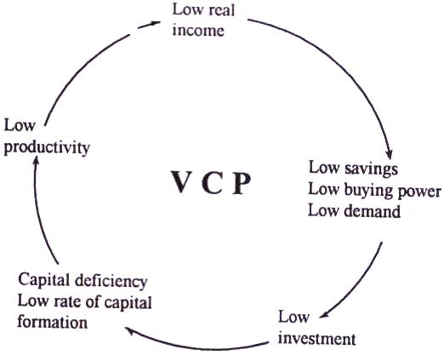

Diagram 2 Nurkse's Vicious Circle of Poverty (VCP)

Nurkse stated that when a country is not economically developing, it is stagnating. According to him this stagnation causes the country to be in this vicious circle of poverty. This can easily be explained by starting at the top of the diagram: with an economically poor country, people have a low real income. This low real income implies that people do not have much to spend, are not in the luxury position to save their money (since they need all the money they have to provide their “life-necessities”) and this causes a low demand for the companies. The low demand causes the companies to have a low profit and limits their possibilities to invest. This causes the capital deficiency for the whole economy, since there is no capital either among the inhabitants of the country nor among the companies in the country. The companies have no possibility to expand their productive capacity, which causes low productivity and brings us back to low income.
Nurkse did come up with a way out of this vicious circle of poverty. His answer to economic stagnation and reason for economic development is massive investments to enlarge the market. He mentions that the investment programme must be massive and balanced. He turns to his theory of balanced growth, also called ‘the doctrine of balanced growth’. The investment in multiple industries causes that they can invest, expand their productive capacity and therefore break the vicious circle of poverty. According to Nurkse these investments in different industries will support each other, since the people working in the industry that is invested in, will receive a higher income and spend their money in the other industries that are invested in. In Nurkse’s words, what is needed is a “more or less synchronised application of capital to a wide range of different industries. Here is an escape from the dead lock, here the result is an overall enlargement of the market ... most industries catering for mass consumption is complementary in the sense that they provide a market for and thus support each other.”. The following diagram (3) shows Nurkse’s main theory of economic growth in a country:

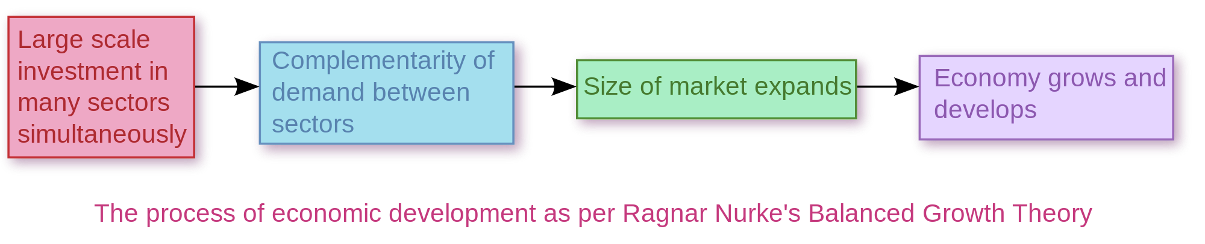
Diagram 2 Ragnar Nurke's Balanced Growth Theory

b. Keynes & Harrod-Domar

Nurkse’s theory is quite similar to the nowadays often-used Keynesian Growth Model. Keynes did not come up with this himself, since he did not extend his theory of demand-determined equilibrium into a theory of growth. The Keynesian Theory opposed the classical theory, which believed in a strong general tendency of the market mechanism towards full employment. Keynes explained that in some situations full employment is not an automatic response in the market mechanism and that the government should invest in companies in order for the economy to grow. Keynes argued that the economy’s equilibrium level of output and employment might not always correspond to the full employment level of income. His theory of the determination of equilibrium income and employment focuses on the relationship between aggregate demand (AD) and aggregate supply (AS). AD is the “Total level of demand for desired goods and services (at any time by all groups within a national economy) that makes up the gross domestic product (GDP). Aggregate demand is the sum of consumption expenditure, investment expenditure, government expenditure, and net exports”. AS is the “Total of all goods and services (including exports and imports) supplied at every price level, within a national economy during a given period. Also called total output”. The theory believes that “demand creates its own supply”, rather than the classical claim of “supply creates its own demand”. This means that when the aggregate demand is enlarged, the aggregate supply will rise as well, to the product capacity of a country creating full employment. To push the AD upwards the government must either invest or create a policy that enhances this increase in AD. This can be seen in the following graph (2):
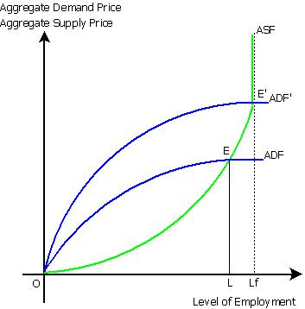
Graph 2 Determination of Full-Equilibrium Employment

The ASF (Aggregate Supply Function) becomes vertical when full employment is reached, which means that the product capacity of a country is at its maximum. If ADF (Aggregate Demand Function) crosses ASF before it becomes inelastic (vertical), the productive capacity isn’t used optimally, which causes unemployment and loss of profit that could be made when this would be used optimally. This must be prevented, and therefore this Keynesian view pleas for a government that invests in companies, allowing the price to decrease and the demand to rise (ADF increases), or to implement a fiscal policy (which means a rise in government expenditure).
The growth model that was born from this theory was based on three basic principles: the economic system may not tend to full employment, investments decision are not dependent on saving decisions and the autonomous components of demand may affect the rate of growth from the economy. Roy F. Harrod was the first economist to come up with a theory of growth and the founder of the modern growth theory. He based his theory on the assumption that all saving is absorbed into investment. This assumption causes the need for an increase in savings, which will then lead to an increase in investment. Together with the ideas of Evsey Domar (a Russian American Economist), the Harrod-Domar Growth Model was created. This model can easily be understood through the following diagram (4), which shows the structure of the Harrod-Domar model as published in iThink®/STELLA® by the economist dr. Mohammead Mojtahedzadeh:

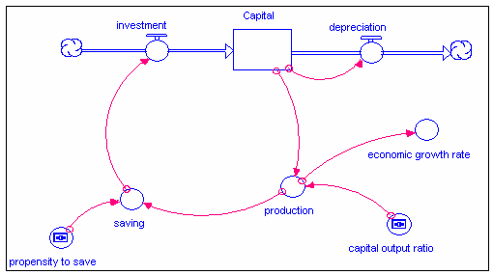
Diagram 3 Harrod-Domar Model of Economic Growth
“The diagram presents three important aspects of the model, which one can easily see and recognize. It shows the stock of capital and the flows (investment and depreciation) that change the stock. The diagram reveals the reinforcing process that creates the economic growth. A higher stock of capital leads to a higher production, which leads to higher savings in turn lead to a higher investment, which increases the stock of capital. The diagram shows a balancing process that tends to offset the rate of economic growth. A higher stock of capital leads to higher depreciation, which decreases the stock of capital.”

c. Jagdish Bhagwati and Arvind Panagariya

Jagdish Bhagwati is a very prominent Indian economist, best known for his work on trade. Bhagwati is professor of economics at Columbia University and has been nominated for Nobel Prizes several times. He mainly focuses on the question of what India must do to keep booming and maintain its economic growth. Bhagwati’s theory is close to Harrod’s theory of growth, which is often used as the standard economy theory (of growth). He thus represents the ‘classical’ approach towards the Indian economy. According to Bhagwati, only one strategy can help the poverty in a country: this is economic growth, led by markets overseen and encouraged by liberal state policies. His main point is that “if you want it to work, you need growth. With all that implies”. In his latest book, which was written together with his colleague Arvind Panagariya (an Indian-American economist and also professor of Economics at Columbia University), he “debunks” a number of “myths” on India’s economy and tirelessly pleads the cause of “economic growth”, not just as a model for India, but as a model for the developing world as a whole, with India setting an example. The story of India’s economic development they tell is a simple one: the disasters of the socialist-style five-year plans could not help India, but liberalisation opened the way to a better future. An even better future awaits India, if it continues to create the opportunities for economic growth. These are, largely, the points of view of liberal institutions like the World Bank and the IMF – and it is not surprising that Arvind Panagariya spent most of his working life in the service of these and similar institutions. What is important to them, it seems, is that India would be the prime example of the possibility for developing countries to combine a democracy with economic growth.
As this example shows, their interests are far from purely economic, but spread out to the domains of politics and social justice, where they represent the Western liberal perspective. Together, Bhagwati and Panagariya are behind the highly influential Columbia University Program on Indian Economic Policies, which maintains a website with many policy papers, and seems to be influential in the actual development of India’s economic (and other) policies.
When it comes to the questions this report wants to ask, the position of Bhagwati and Panagariya is predictable: economic growth and liberalization first, the rest will follow. They describe this as a “two track-system” in their book Why growth matters. The first track is directed towards economic growth alone, governed by reforms that are designed directly to benefit economic growth, such as trade liberalization. This is the track India is (or should be, according to the authors) on – and there is no alternative for it. Track II then tackles the factors of a democracy that might lead to growth or are causing the stagnation in a country. What this comes down to is the following: poverty relief (and all other indicators of social justice) is a matter of the redistribution of income, but for this to be possible, there must be income to distribute. Therefore, growth goes before all possibilities of improving living conditions. In this view of economy, politics, and social justice, the economic role of government has become very reduced, almost to the level of taking instructions from the IMF – because it cannot do anything other than allowing growth to happen: everything else they do would probably impede the development they need if they ever want to do something for the poor.

2.2 Amartya Sen

Amartya Sen is an Indian economist, who was awarded the Nobel Memorial Prize in Economic Sciences in 1998 for his work on welfare economics. He is a professor at Harvard University and is known for his extensive research and work on India. Sen describes the contradiction of India’s booming economy on one hand, but the extreme poverty for large parts of its population on the other hand in his most recent book called “An Uncertain Glory: India And Its Contradictions” (first published in 2013, written with Jean Drèze). He is best known for his work on public choice and development. In most of his works he combines an interest in economics with matters of individual, group, and societal justice. For him, the economy is part of a larger web of relations, which can create (or maintain) good or bad circumstances for individuals, groups, and society as a whole – and when these circumstances are bad, they are likely to have a negative effect on the economy in turn. Thus, it becomes a circle. The numerous standard economic theories of growth are all focussed on increasing the capital, expanding productive capacity and increasing the GDP in/of a country. Sen has come up with a completely new and different view of economic development. He does not focus on investing and increasing capital, but instead he focuses on improving the lives of the people in a country. He thinks that the standard economic theory of growth fails to understand that social freedoms and things like the opportunity to receive basic education contribute to economic development and growth. In his opinion, these freedoms are among the components of development. In his eyes something that contributes to development does not necessarily mean it has to contribute to the growth of the GDP directly or indirectly. In Sen’s words:

“the usefulness of wealth lies in the things that it allows us to do- the substantive freedoms it helps us to achieve….an adequate conception of development must go much beyond the accumulation of wealth and the growth of gross national product and other income-related variables. Without ignoring the importance of economic growth, we must look well beyond it”

When we compare this approach with that of Bhagwati, the primary difference in approach is that Bhagwati argues that poverty and its social dimension can be taken care of only in the second step of the development, while Sen argues that this is an equally important, if not more important, step in the developmental process. This difference in approach can be seen when comparing their differences in opinion on the East Asian case. In East Asia multiple countries (called the ‘Asian Tigers’) such as Japan and South Korea achieved huge rates of growth in the 80’s and 90’s. Important to notice is that they combined this with an improvement of their social factors, such as literacy rates. Sen saw this as just another example supporting his argument that factors such as social freedoms are not the second step towards economic development, but the first. Bhagwati, on the other hand stated:

“The East Asian investment rate began its take-off to phenomenal levels because East Asia turned to the Export promotion (EP) strategy. The elimination of the ‘bias against exports’, and indeed a net excess of the effective exchange rate for exports over the effective exchange rate for imports (signifying the relative profitability of the foreign over the domestic market), ensured that the world markets were profitable to aim for, guaranteeing in turn that the inducement to invest was no longer constrained by the growth of the domestic market as in the IS strategy”.

While Sen explained economic development as a consequence of social achievements, Bhagwati states that social achievements followed on the stage of growth, meaning that this is the second step in economic development and growth. It is impossible not to notice, in this respect, that Bhagwati and Panagariya frequently lash out to Sen in very aggressive ways, while Sen simply seems to ignore the contributions by Bhagwati and Panagariya. This strongly suggests that this is not a debate between economists alone, but more a matter of clashing world-views.

For the purpose of this report, it may be useful to summarize the two positions in strongly oppositional terms. For Bhagwati and Panagariya, economic growth is a necessary condition for the improvement of social justice, since without it, there would be nothing to distribute. Governments mainly play the role of enablers of international economic, financial and business forces to do their positive work – and this governments do by refraining from interfering as much as they can. Any political, and certainly any social agenda, would harm the growth of the economy, and thus impede progress towards freedom.
For Sen, on the other hand, social justice is a necessary condition for real economic growth. He memorably describes the current situation of India as one of “islands of California in a sea of sub-Saharan Africa” and strongly suggests that this is not a sustainable situation. At this point, we have reached the stage that we must confront these clashing points of view with the actual numbers of India’s development.

Chapter 3
Number Crunching:
Economic Indicators of India’s Economic Performance

As we discussed in the previous chapter, Sen focussed on numerous topics besides just the GDP or other factors based on money (like investments) to conclude weather a country is economically developing or not. When discussing India it is necessary to take a look at how the statistics on these social indicators have changed over the years, with its economy booming. Is this booming economy noticeable for the inhabitants of the country? How have the social indicators changed?

Before we can reach any conclusion on the interrelations between economic development and social justice – the core issue of this PWS, and the core difference between Sen, classical economists and Bhagwati – we need to have a look at some figures. Information about a whole range of development indicators – financial, economic, social, cultural, etc. – can be accessed in many different places. The first place to look is probably the Census of India, but the figures presented there are far from complete, sometimes difficult to access and mostly non-historical, in the sense that they do not give evidence for long-term developments, only (occasionally) between the last census (of 2001) and the most recent one of 2011.
Fortunately, the World Bank has an extensive country report on India, with a huge database of figures, scoring India on 1340 indicators, over a period ranging from 1961 to 2013. Many of these indicators are, of course, economic and financial, but they also include much information on social development. These figures form the basis of the present chapter.

This chapter will focus on three key areas: women; health; and education and literacy. It will discuss these areas separately, chiefly in the form of graphs on several indicators, measuring development over five decades

3.1 Women in the Modern Indian Society

The population of India is characterized by a serious – and ultimately threatening – gender imbalance, which has remained stable over a fairly long period. As opposed to a “natural” ratio of 1010 men to 1000 women, the census of India shows that on a nation-wide level, there are only 943 women (up from 933 in 2001) for every 1000 men. The accompanying graph shows the relative stability of this situation up 2001.
Remarkably, however, the picture is very different if we only look at the group of 0-6 year olds. There, the figures show that the gender imbalance has widened at a frightening pace, from more than 960 girls per 1000 boys in 1961 to under 930 in 2001:

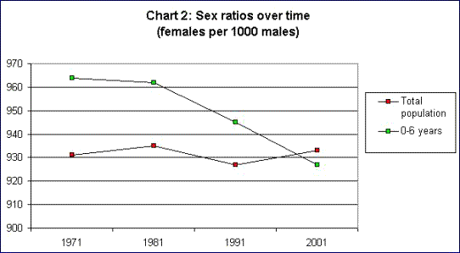
Graph 3 Sex Ratios over time (females per 1000 males)

The explanation for this situation (as seen in graph 3) seems to be relatively easy: women live longer than men and therefore ‘close’ the gender gap by outliving men, but they start from a very difficult position, which can only be explained by cultural preferences for sons (and the attendant practices of abortion of female foetuses, or actual infanticide on girls). Amartya Sen has pointed several times at these problems, and has further shown how the ‘gender gap’ is regionally patterned: in some states of South India, there are actually more girls than boys, and one state in the North, the Punjab, is particularly grim – with only 793 girls for every 1,000 boys.

There are clear indications of improvements in women’s health (see the next section), that are caused especially by better medical care and attention surrounding childbirth. Not only have the numbers of perinatal and child mortality plummeted (neonatal death from 1,4 million to 750,000 between 1990 and 2013; mortality rate of under-five year olds down from 243 per 1,000 children in 1961 to 53 in 2013), maternal deaths, too, have decreased enormously (in absolute numbers from 150,000 in 1990 to 50,000 in 2013).

Most of the work done by women remains invisible and uncharted. These are their domestic activities, as mothers, wives, and house-keepers. This is especially true of their enormous invisible role in India’s agriculture. This may help to explain the relative lack of increase in women’s participation in salaried work of whatever kind, but the figures for that particular subject are dramatic. Women are massively underrepresented in the Indian labour force, and for many of the indicators, the situation has been getting worse rather than improving. Two charts may illustrate this: the first shows labour force participation rates between 1987 and 2000, showing that women’s participation rates were dropping at the very moment that the Indian economy was ‘liberalised’:

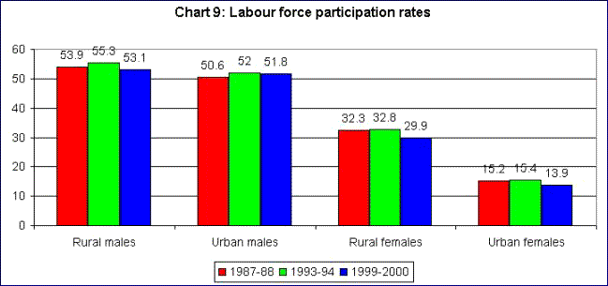
Chart 1 Labour force participation rates
The second chart will give an international comparison, showing that India is outperformed in women’s participation in the labour force by almost all countries in the world, with the exception of very conservative Muslim countries like Saudi-Arabia:
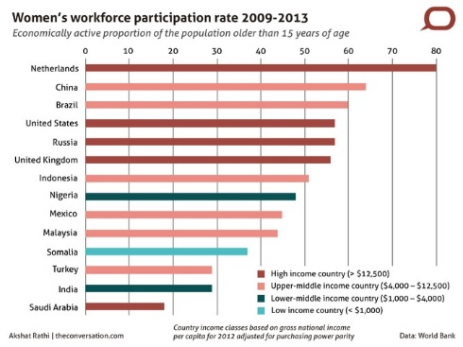
Chart 2 Women participation rate 2009-2013

In sum, the situation of women – in spite of their improving health, literacy and education – cannot really be said to have improved with the change in economic policy. On the contrary, the move to industrialization and urbanization – with the accompanying decrease of the importance of agriculture – seems to have a negative impact on women’s lives, since ‘urban’ women are far less likely to do salaried work than ‘rural’ women.

3.2 Health in Modern India

No less than three of the eight Millennium Development Goals of the United Nations are concerned with issues of health: reducing child mortality; improving maternal health; and combatting HIV/AIDS, malaria and other diseases. With the exception of HIV/AIDS (the prevalence of which is low in India), these are very real issues for modern India. We shall therefore use them as our focus indicators to say something more general about the development of medical health care in India.

- Child mortality

Child mortality must be measured on two crucial moments of the human life: neonatal mortality (children who die during child-birth without being still-born), and infant mortality (children who die before they reach the age of five). On both indicators, enormous improvements have taken place. The Worldbank database shows that neonatal mortality has decreased from 51.1 neonatal deaths per 1,000 births in 1990 to 29.2 in 2013. Infant mortality (of children aged 0-5) has decreased from 243.5 per 1,000 live births in 1961 to 52.7 in 2013.
This is a remarkable development, since these same figures show markedly smaller (in some cases barely traceable) improvements in, for example, the number of hospital beds per 1,000 people (relatively stable at 0.7, if anything a decreasing number), of available community health workers per 1,000 people (0.046 in the most recent year (2005), but only two years have given an indication for this figure), of available midwives per 1,000 people (up from 1.27 in 2004 to 1.71 in 2011), and of available physicians per 1,000 people (up from 0.2 in 1965 to 0.7 in 2012). So it does not seem to be the healthcare system that has improved, but other factors must have influenced these figures. It seems likely, therefore, that the huge increase in what the Worldbank calls “improved water access” has been very important here: this percentage has increased from 70.4 % of the population in 1990 to 92.6 % in 2012.

- Maternal health

Something similar must be said about maternal health. There has been some increase in women receiving prenatal care (from 61.9 % in 1993 to 75.2 % in 2008), and in “births attended by skilled health-staff” (from 34.2 % in 1993 to 52.3 % in 2008), but a much more marked decrease in maternal mortality (from 560 per 100,000 live births in 1990 to 190 in 2013).

- Health expenditure

What is also remarkable is the fact that health expenditure (as percentage of GDP) has fluctuated over the years, with the last few years showing a marked decrease compared to a high point in 2004 (3.5 %; the figures given start in 1995 with 2.9 %, showing years of increasing expenditure culminating in 2004, and then a decrease to the level of 2.7 % in 2012). India’s population, in other words, is getting healthier, but not through direct investments in medical health care.

3.3 Education and Literacy in Modern India

- Literacy

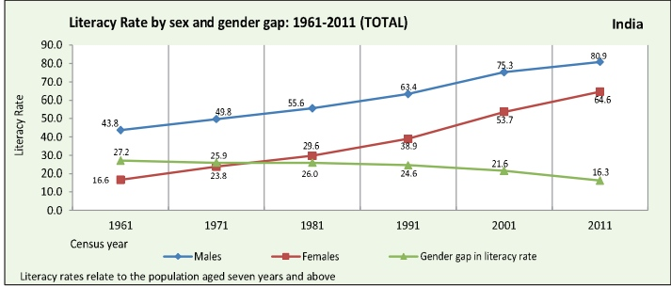
Graph 4 represents the change in literacy rate by sex over the years 1961 to 2011. It is the total amount of literates in percentage from the total population, this means that both people from the rural areas and people from the urban areas are accounted for in the graph. The green line shows the change in the gender-gap between men and women. This line is of importance for topic 3.1 ‘Women in Society’ as well as for the topic of literacy itself. It is noticeable that the literacy rate among both men and women has increased enormously. For women it has quadrupled and for men the number has doubled. This increase of literates and therefore decrease of illiterates tells something about the social standards among the people of India. Since 2011, it has become normal even for women to be literate, as we see the percentage of literates among women has risen above the medium of 50%, whereas in 1961 it was exceptional to be literate. Logically, the gender-gap between men and women when talking about literacy has declined, as women’s literacy rates have quadrupled and men’s literacy rates have ‘only’ doubled. As logical as this is, this also tells us something about the position of women in society. Where men used to think of women as a group of humans who were useful in looking after the household and taking care of the children, women are starting to emancipate and to be treated like individuals, something women in Europe have not had to worry about for two generations now. Being treated equally and like individuals also means having the same freedoms as men have. Reading and writing is an example of a freedom, which has visibly become more common among women, besides just for ‘the higher ranked’ men.
Graph 4 Literacy Rate by Sex and Gender Gap (1961-2011)

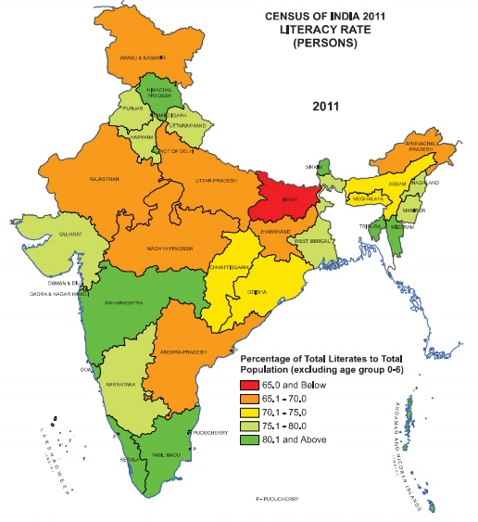
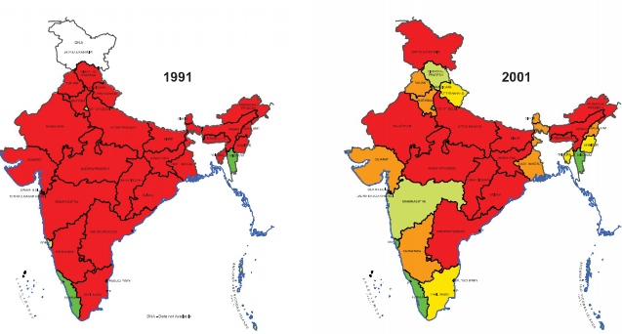
Figure 1 emphasizes this change in literacy rate by showing how the divide in literacy rate in the whole country changed. The dark red areas are the areas where only 65% of the population (in the specific region) or lower are literate. The difference between the 10 years (1991-2011) is immense. In 1991 India was in a fiscal crisis (chapter 1.1 (b)) and whether people could read and write or not was of high importance to the rulers of India at that time. People worried about India’s future and India’s economy. The production had to be high at a low cost, to keep a company from going bankrupt. The low income for the employers did not give them the freedom to learn how to write and this probably was not the first thing they worried about either. But after 1991 India’s economy started to grow. With this growing economy we can see that the literacy rate has increased together with this booming new industrial and economic experience.
Figure 1 Change in Literacy Rate shown in a map (1991-2011)

- Education

Education is a key development factor, since high numbers are not only positive for the moment of research but also point out a bright future. Again the world databank (footnote 29) did a lot of research on the development of education in India. When researching this it is important to keep public spending in mind (graph 5), since a higher public spending (“Money expended by a government to pay for defence, development projects, education, health, infrastructure, law and order maintenance”) should come with improved and higher numbers on development in the area of education. Moreover this will help to find out whether either Sen’s or Bhagwati’s points of view and theories seem to be valid. Is it the improvement of education that allows economical development to take place or is it economical development that brings along improvement in education?

Graph 5 Public spending on education, total (% of government expenditure)
Graph 5 shows the change in public spending on education in comparison with other countries in South Asia. Noticeable is that up until 2010 other countries in South Asia spent way more on education than India, but that today India spends more on education than other countries in South Asia. However this increase in public spending on education is relatively small with an exact number of only 0,6% (from 10,7% (2005) to last recorded 11,3% (2012)). But if we compare this increase of 0,6% with the growth of the GDP that has evolved from 721.6 billion US dollars in 2005 to 1880.1 billion dollars in 2012, the increase in government expenditure is huge. The graph mostly shows that the other South Asian countries have started spending less on education.

But how has this influenced the actual education numbers in India? Graph 6 shows total change in school enrolment to the primary school again in comparison to other countries in South Asia.

Graph 6 School enrolment, primary (% gross)

Again there is not an immense difference in school enrolment. However, in comparison with 1971 the difference is huge. In 1971 the gross percentage was only 78%. So with the booming economy, the amount of children enrolled to school went sky high for India, and remains higher than most other countries in South Asia.

All in all, these are relatively positive numbers for India. The high percentage of school enrolments seems to suggest that education is important for the country, that it may be of a high quality and that it is seen as a right all citizens can claim. But, as Sen repeatedly mentions in his book “An Uncertain Glory”, these numbers say nothing at all about the quality of education. Sen mentions “two principal deficiencies: firstly, limitation of coverage, and secondly, poor standards of the education that is offered and received”. While this first deficiency is being improved and is the one the government only focuses on when trying to improve their education, the quality of education in India turns out to be extremely low.
One chapter of “An Uncertain Glory” is dedicated to explaining the educational standards. The ‘Pisa Plus’ survey, conducted in 2009, showed that India’s performance on education comes out at the very bottom of the 74 countries that participated in the survey. An example of such a poor performance is the ability to read for 15-year-olds. It showed that in comparison with other countries, the two Indian states that participated (Himachal Pradesh and Tamil Nadu) ended in the bottom three. In other tests, like mathematics and science education, Indian students were similarly outperformed by students from other countries, with the exception of Kyrgyzstan.
In addition to this low-quality education there is a difference in educational accomplishments between different regions. This can be seen through analysing the Indian Human Development Survey (IDHS):

Table 1 Pupil Achievements in Major States, 2004-5
 | Read | Subtract | Write
Himachal Pradesh | 81 | 64 | 77
Kerala | 80 | 64 | 84
Tamil Nadu | 78 | 67 | 82
Assam | 73 | 45 | 97
Maharashtra, Goa | 65 | 53 | 71
Haryana | 63 | 58 | 61
Gujarat | 60 | 36 | 64
Chhattisgarh | 58 | 31 | 46
Odisha | 58 | 48 | 73
Punjab | 54 | 61 | 65
Uttarakhand | 53 | 35 | 62
Jharkhand | 51 | 54 | 56
West Bengal | 51 | 56 | 72
Rajasthan | 50 | 37 | 53
Karnataka | 45 | 48 | 76
Andhra Pradesh | 44 | 46 | 62
Bihar | 40 | 43 | 65
Madhya Pradesh | 39 | 25 | 38
Uttar Pradesh | 29 | 22 | 51
Jammu & Kashmir | 26 | 50 | 67
India | 50 | 43 | 64

Table 1 shows the percentages of the total amount of children between 8 to 11 years old, who are enrolled in a government school, who are able to read, subtract or write. The two states (Himachal Pradesh and Tamil Nadu) that participated in the Pisa Plus survey are the two states that score best of India when comparing regions to each other. This means that while these educational standards and accomplishments are already worse than other countries, the performance of students in India living in other regions tends to be even worse. According to Sen in the seven large Indian states, that together make up half of India’s population, the number of children between 8-11 years that are able to pass a very simple reading test varies between one fourth and a half, a shocking low number when keeping in mind that in the Western Countries almost all children aged 6-8 are able to pass the same test.

Chapter 4
Conclusion: Economic Growth and Social Justice

In the preface to his remarkable book An Uncertain Glory, Amartya Sen writes the following:

“While India has climbed rapidly up the ladder of economic growth rates, it has fallen relatively behind in the scale of social indicators of living standards, even compared with many countries India has been overtaking in terms of economic growth.”

The numbers we have reproduced in chapter three seem to suggest that he is right, or at the very least that the simple version of Bhagwati’s position on the question addressed in this project report is not supported by the facts. But while Sen’s observations on the ways in which India is failing its citizens may be correct, this does not mean that his theoretical idea of social justice as a condition for sustainable economic growth is correct. It is time, therefore, to retrace our steps.

This project attempted to answer the question of the interrelation between economic growth, individual rights and social ties. I have summarized the final two categories in the term ‘social justice’. It includes things like equal rights for all: access to political representation, health care, education, and safety for all citizens of a country, regardless of their gender, religion, race, caste, or (crucially) wealth. It is well known that India is performing well on some of these indicators, but very poorly on others. The situation of women in India in particular is very poor, and has not improved noticeably with the booming economy. This has been visible to the whole world with a string of horrible rape-cases in the past few years, in which working women and female students were usually the victims. The same is true for the situation of the so-called “scheduled castes” (previously “untouchables”), for whom special government protection programmes have been installed, but many of whom still live in the margins of Indian society, and are frequently the victims of violence and poverty.

The standard economic story of India makes a distinction between the first 45 years after independence and the period since the liberalisation of 1991. These first 45 years were inspired by socialist economic policies: interventionist, protectionist and largely serving a social agenda. This ended in a fiscal and monetary crisis, following which the IMF forced India to change course. India adopted liberal economic policies in 1991 and has witnessed a remarkable growth since then. This no one denies, nor does anyone deny that the shift from interventionism and protectionism to a free market economy was a wise one in economic terms. But what did this mean for India’s people? How did they benefit from the rise in GDP? How does “economic prosperity” or economic growth translate into prosperity or growth Indians themselves experience? Why does India not only top the list of developing economies, but also the lists of poverty, inequality, corruption, and violence? To this question, two very different answers have been given, both by Indian-born economists who are currently working in America. On the one hand, Jagdish Bhagwati and Arvind Panagariya have defended the ‘classical’ liberal logic, and used it to explain India’s present and to sketch an agenda for India’s future. For them, economic growth will lead to surplus wealth, which will lead to redistribution, which will help the poor. On other aspects of India’s social problems, they have little to nothing to say – perhaps because they do not see these problems as having a relation with economic questions.

On the other side of the debate, we find Amartya Sen, who basically argues that social justice should go hand in hand with economic growth, or (preferably) should precede it. He says that a government cannot congratulate itself on economic development, if it is unable to ensure that its citizens’ lives are actually improved. He also says that in the case of India, this improvement is not taking place, and that that should be at the top of the agenda, rather than purely monetary economic policies.

Both men, we can conclude, interpret “growth” differently: the one in terms of a growing GDP and in other monetary ways, the other in a much more expansive way as indicating all types of “development”. Both men, moreover, clearly cross the boundaries of their jobs as professors of economics, and quickly move into the realm of political and social policy advice. This they do, there is no doubt for anyone who has read their books, out of love for India.

In order to test these various claims, we have had a look at some of the performance indicators the World Bank and the Census of India work with, preferably those which can give an indication over a longer period, so that we could compare development before 1991 with the period since 1991. We have chosen the position of women, health, and education and literacy – three domains that are important also in economic terms (labour force, worker’s health, and level of education are all factors that have a noticeable impact on production).
The numbers do not immediately support Bhagwati and Panagariya in these domains. The very slow and unstable economic development before 1991 and the very quick economic development since 1991 are not traceable in these social patterns of development. Indicators of health have been improving slowly but steadily since 1961, with no noticeable change for the better since 1991 – in fact, in some respects the situation has either remained stable or worsened. The same is true for literacy – a steady rate of development. In terms of education, it seems to be the case that we witness a numerical growth only – but that the quality of education has not improved. The situation of women, finally, has not improved at all; on the contrary, women’s labour participation has decreased. None of this supports the optimism of Bhagwati and Panagariya, that economic growth will automatically lead to social progress.
The case of Sen is different. He does not predict economic development, but makes it dependent on social improvement. This is not a position that can easily be tested by looking at performance indicators, since that will always result in a “chicken-or-the-egg” discussion. There is nothing in the figures that suggests that the growing literacy rates and improvement in health, etc., actually caused the economic growth – only that it preceded it (a little bit).
What we do see is that the wealth that India got through the economic growth, is not directly visible in the actual lives of most people living in India. Much of the wealth only reaches the very rich, and growing middle classes, but leaves the other half of India’s population poor, sometimes extremely poor, without any positive change due to the growing economy. If the government does not intervene here, the situation will not change, and the two halves of Indian society will continue to drift apart.

What this has taught me, is that the question of the interrelation between economic growth, individual rights and social ties is not a purely economic question. The role of the government is crucial and I see no reason to adopt Bhagwati’s perspective, which basically says that the government should not do anything other than liberalizing the economy and creating further economic growth (in terms of a growing GDP). On the other hand, I cannot follow Sen’s experiment – for that is what it is – since there is so little evidence to support his notion that social progress will lead to economic development. India’s problems are real, and they are extreme. It is a very complex society, whose problems cannot be reduced to one simple theory, and cannot be made subject to a big social experiment. The government should aim to relieve India’s poor, therefore, not in the hope of creating even more economic growth, but because it cannot continue to fail half of its citizens.
Bibliography

Acemoglu, D. and J.A. Robinson (2012), Why Nations Fail. The Origins of Power, Prosperity, and Poverty, London: Profile Books.

Anonymous websites:
http://www.thefreedictionary.com/caste
http://guweb2.gonzaga.edu/faculty/brunell/ppindia.html
http://economicsconcepts.com/nurkse's_model_of_vicious_circle_of_poverty_(vcp).htm
http://www.businessdictionary.com/definition/aggregate-demand.html
http://www.businessdictionary.com/definition/aggregate-supply.html
http://wikieducator.org/KEYNES%27S_THEORY_OF_AGGREGATE_DEMAND
http://indianeconomy.columbia.edu/
http://www.businessdictionary.com/definition/public-spending.html
http://www.tradingeconomics.com/india/gdp

Bhagwati, J. and A. Panagariya (2013), Why Growth Matters: How Economic Growth in India Reduced Poverty and the Lessons for Other Developing Countries, New York: PublicAffairs.

Census of India (2011): http://censusindia.gov.in
http://www.censusindia.gov.in/2011census/PCA/PCA_Highlights/pca_highlights_file/India/Chapter-1.pdf
http://www.censusindia.gov.in/2011census/PCA/PCA_Highlights/pca_highlights_file/India/Chapter-3.pdf

Drèze, J. and Amartya Sen (2013), An Uncertain Glory. India and its Contradictions, London, New York: Penguin.

Dhar, A. (2012), Indian students fare poorly in international evaluation test,
http://www.thehindu.com/news/national/indian-students-fare-poorly-in-international-evaluation-test/article2804134.ece

Ghosh, S., The Indian Economy since Independence, http://home.fau.edu/sghosh/web/images/India%20talk.pdf

Jayeshe (not known), What is the Theory of Balanced Growth?,
http://www.preservearticles.com/2011103116267/what-is-the-theory-of-balanced-growth.html

Macroscan: Alternative Economics Webcentre:
http://www.macroscan.org/fet/aug02/chart/Women/chart2.gif
http://www.macroscan.org/fet/aug02/chart/Women/chart9.gif

Means, B. (2013), Nonmarket Values in Family Businesses, in: William and Mary Law Review 54, pp. 1185-1250.

Mojtahedzadeh, M. (2003) Understanding Economic Dynamics,
http://www.iseesystems.com/community/connector/Zine/may-june_2003/economicdynamics.html

Organisation for Economic Co-operation and Development (OECD), www.oecd.org
http://research.acer.edu.au/cgi/viewcontent.cgi?article=1000&context=pisa

Panagariya, A. (2014), The Promise of Modinomics; How the New Prime Minister can bring back Growth, in: Foreign Affairs, http://www.foreignaffairs.com/articles/141556/arvind-panagariya/the-promise-of-modinomics

Pratap Kumar, P. (2013), Andhra Pradesh: Economic and Social Relations, in: P. Berger & F. Heideman (eds.), The Modern Anthropology of India: Ethnography, Themes, and Theory, London: Routledge, 2013, pp. 12-28.

Quartz: http://qz.com/176658/india-has-the-lowest-workforce-participation-rate-of-women-among-the-brics

Rainer Kattel, J., A. Kregel, and E.S. Reinert (eds.) (2011), Ragnar Nurkse (1907-2007): Classical Development Economics and Its Relevance for Today, London, New York: Anthem Press.

Rudolph, S.H. and L.I. Rudolph (2001), Living with Difference in India: Legal Pluralism and Legal Universalism in Historical Context, in: G.J. Larson (ed.), Religion and Personal Law in Secular India: A Call to Judgement, Bloomington: Indiana University Press, pp. 36-65.

Sen, A. (1999), Development As Freedom, New York: Knopf and Oxford: Oxford University Press.

Sen, A. (2003), ‘Missing Women – Revisited: Reduction in Female Mortality has been Counterbalanced by Sex Selective Abortions’, at http://www.ncbi.nlm.nih.gov/pmc/articles/PMC286281/?tool=pubmed

Srinivasulu, K. (2002), Caste, Class, and Social Articulation in Andhra Pradesh: Mapping Differential Regional Trajectories, Overseas Development Institute working paper 179, London 2002, http://www.odi.org/sites/odi.org.uk/files/odi-assets/publications-opinion-files/2692.pdf

The Hindu (2012), http://www.thehindu.com/news/national/indian-students-fare-poorly-in-international-evaluation-test/article2804134.ece

United Nations: http://www.un.org/millenniumgoals/

World Bank: http://databank.worldbank.org/data/views/reports/tableview.aspx
http://data.worldbank.org/country/india

As such, they are extremely “extractive”, and therefore likely to fail (in the end), according to D. Acemoglu & J.A. Robinson, Why Nations Fail. The Origins of Power, Prosperity, and Poverty, (London 2012)
I have used the digital version of this chapter on the website dedicated to Angus Maddison’s work: http://www.ggdc.net/maddison/oriindex.htm (last accessed 7 December 2014; Angus Maddison (1926-2010) was professor of Economics in Groningen).
Maddison 1971: 22 (on the website mentioned in the previous footnote), emphasis added (SdJ).
These are always judged to have been economic failures, but this evaluation may be slightly off the mark, if one considers the policies from the background of a greater necessity for social than for economic reform.
http://guweb2.gonzaga.edu/faculty/brunell/ppindia.html (last accessed 23-11-2014)
Data provided by the World Bank: http://databank.worldbank.org/data/views/reports/tableview.aspx (last accessed 7 December 2014)
http://www.thefreedictionary.com/caste (last accessed on 7-12-2014)
K. Srinivasulu, Caste, Class, and Social Articulation in Andhra Pradesh: Mapping Differential Regional Trajectories, Overseas Development Institute working paper 179 (London 2002)
See also P. Pratap Kumar, ‘Andhra Pradesh: Economic and Social Relations’, in: P. Berger & F. Heideman (eds.), The Modern Anthropology of India: Ethnography, Themes, and Theory, (London: Routledge, 2013) pp. 12-28
BJP = Bharatiya Janata Party (“Indian people’s party”); RSS = Rashtriya Swayamsevak Sangh (“National Volunteer Organization”); VHP = Vishva Hindu Parishad (“World Hindu Council”).
S.H. Rudolph & L.I. Rudolph, ‘Living with Difference in India: Legal Pluralism and Legal Universalism in Historical Context’, in: G.J. Larson (ed.), Religion and Personal Law in Secular India: A Call to Judgement (Bloomington 2001) pp. 36-65.
This project report attempts to fill some of the former gaps; for the latter, see (from a legal perspective) B. Means, ‘Nonmarket Values in Family Businesses’, William and Mary Law Review 54 (2013), 1185-1250.
R. Nurkse, Classical Development Economics and Its Relevance for Today, (edit of R. Kattel, J. A. Kregel & E. S. Reinert) (Londen 2011), p.89-97
http://economicsconcepts.com/nurkse's_model_of_vicious_circle_of_poverty_(vcp).htm (last accessed on 13-12-2014)
http://www.preservearticles.com/2011103116267/what-is-the-theory-of-balanced-growth.html (last accessed on 7-12-2014)
http://www.businessdictionary.com/definition/aggregate-demand.html (last accessed on 7-12-2014)
http://www.businessdictionary.com/definition/aggregate-supply.html (last accessed on 7-12-2014)
http://wikieducator.org/KEYNES%27S_THEORY_OF_AGGREGATE_DEMAND (last accessed on 7-12-2014)
Earlier mentioned - Chapter 1. India After Independence, this however is a different part of model focussing on poor countries (the part discussed in this chapter talked about the capital output ratio also shown in diagram 4)
http://www.iseesystems.com/community/connector/Zine/may-june_2003/economicdynamics.html (last accessed on 13-12-2014)
http://www.iseesystems.com/community/connector/Zine/may-june_2003/economicdynamics.html (last accessed on 13-12-2014)
This is basically the summary of J. Bhagwati& A. Panagariya, 2013 - Why Growth Matters: How Economic Growth in India Reduced Poverty and the Lessons for Other Developing Countries
See A. Panagariya, ‘The Promise of Modinomics; How the New Prime Minister can bring back Growth’, in Foreign Affairs at http://www.foreignaffairs.com/articles/141556/arvind-panagariya/the-promise-of-modinomics (last accessed on 13 December 2014): [India’s] “track record busted the myth that democracy hinders economic growth – a common conclusion among many looking at the growth of authoritarian China, Singapore, Taiwan, and (in an earlier age) South Korea”.
http://indianeconomy.columbia.edu/ (last accessed on 13 December 2014).
Sen, A. 1999 – Development As Freedom, New York 1999, p. 14.
See the discussion of Suman Ghosh, ‘The Indian Economy since Independence’, http://home.fau.edu/sghosh/web/images/India%20talk.pdf (last accessed 13 December 2014), from which this reference to Bhagwati was taken.
A. Sen, An Uncertain Glory: India and its Contradictions, (2013) p. ix.
http://censusindia.gov.in (last accessed on 09-12-2014).
http://data.worldbank.org/country/india (last accessed on 09-12-2014)
http://www.censusindia.gov.in/2011census/PCA/PCA_Highlights/pca_highlights_file/India/Chapter-1.pdf (accessed on 09-12-2014).
http://www.macroscan.org/fet/aug02/chart/Women/chart2.gif (13-12-2014)
A. Sen, ‘Missing Women – Revisited: Reduction in Female Mortality has been Counterbalanced by Sex Selective Abortions’, at http://www.ncbi.nlm.nih.gov/pmc/articles/PMC286281/?tool=pubmed (13-12-2014).
http://www.macroscan.org/fet/aug02/chart/Women/chart9.gif (13-12-2014)
http://qz.com/176658/india-has-the-lowest-workforce-participation-rate-of-women-among-the-brics (last accessed on 13-12-2014)
http://www.un.org/millenniumgoals/ (last accessed on 13-12-2014).
http://www.censusindia.gov.in/2011census/PCA/PCA_Highlights/pca_highlights_file/India/Chapter-3.pdf (last accessed on 09-12-2014)
http://www.businessdictionary.com/definition/public-spending.html (last accessed on 13-12-2014)
http://www.tradingeconomics.com/india/gdp (last accessed on 13-12-2014)
Sen, A. – An Uncertain Glory, p. 124
PISA stands for Programme for International Student Assessment; it is a part of the Organisation for Economic Co-operation and Development (OECD; www.oecd.org). For the 2009 PISA Plus survey, in which India did not take part as a nation, but was represented by two of its states, Himachal Pradesh in the North and Tamil Nadu in the South, see the report of the Australian Council for Educational Research at http://research.acer.edu.au/cgi/viewcontent.cgi?article=1000&context=pisa (accessed 13-12-2014). For a response to the findings in the Indian press, see http://www.thehindu.com/news/national/indian-students-fare-poorly-in-international-evaluation-test/article2804134.ece (accessed 13-12-2014)
Sen, A. An Uncertain Glory, p. 125
Sen, An Uncertain Glory, p. ix.

