Memory book guide

Memory book

The memory book
Every child in Sunrise is supposed to have a memory book, just for their own. At first a memory book is just an empty case, but throughout the years it will be filled with memories, created by the child itself. It can be filled with all kinds of personal items such as assignments, thoughts, arts & crafts or photo’s. By creating this book the child gets the opportunity to take memories from their youth to future life. And as a great second circumstantial, the children can actively discover who they are, what they want and what they are capable of. And with a little help they can accomplish these goals, in a creative and fun way. Enjoy!

How to work with the memory book
The memory book guide contains all kind of worksheets; they do not have to be completed in a particular order. Feel free to interpret the worksheets in a creative and fun way. When you completed a worksheet, make sure that you check off that worksheet in the index. The index can be found at the back of the memory book of every child.
Please note that we tried to create worksheets which help the children to actively discover and develop themselves. Some worksheets may be too difficult or too easy for some children, because the children are from different ages and they all develop in their own pace. Therefore you can just pick a worksheet which you think will fit the development level, experience, age and/or occupations of a child.
Note for volunteers
This guide contains all kind of assignments which you can do with the children but these assignments are just suggestions. If you want to do other assignments with the children, which are in line with the goals of a memory book, please feel free to do so. Also when you feel there is something missing in this book, feel free to add it to the guidebook (a digital version is available at the VSN office).
Please, always check if there’s enough art material left in the closet. Maybe you collected some sponsor money from friends and family. You can think about buying some new materials for the memory books (for example available in Koteshwor). It’s not really expensive and the kids will love it!

Worksheet 1: Draw your hand true to nature
Date:
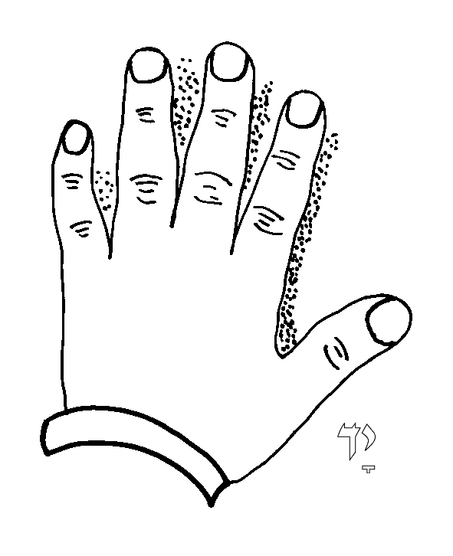
Place your hand on a piece of paper and track it with a pencil. Afterwards you take your hand off the paper. Add nails, freckles and everything else that is visible on your hands. Try to make it as true to nature as you can.

Worksheet 2: Draw your hand aArtistic
Date:
Place your hand on a piece of paper and track it with a pencil. Afterwards you take your hand off the paper. Than you can color your hand, just how you’d like to.

Worksheet 3: Mirror, mirror on the wall
Date:
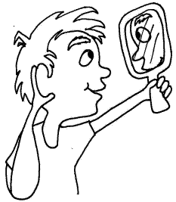
How do you look like in the mirror? Take a mirror (or a photograph of yourself) and try to draw yourself close to nature.

Worksheet 4: My body
Date:
How do you feel about your body? What parts of your body do you like the most? You can write it down and/or color the parts you like the most in the body outline below.

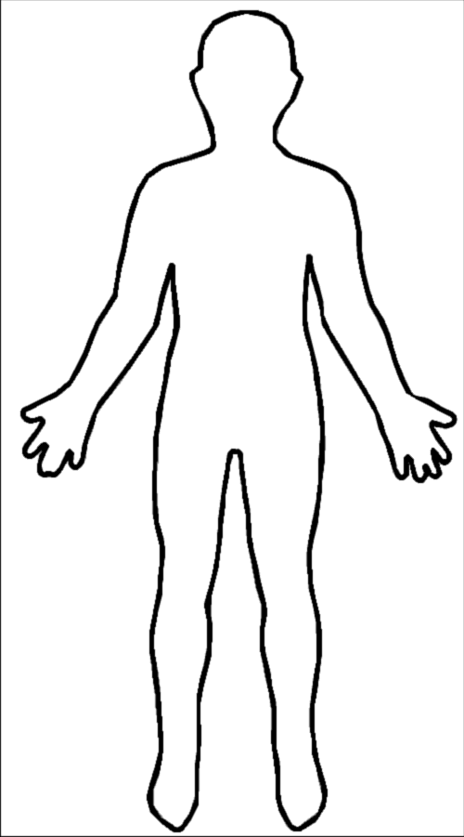

Worksheet 5: Design your own clothes
Date:
What do you like to wear? Do you like you pajamas, your training outfit or would you rather wear a beautiful suit or dress? You can draw and/or design your clothes in the body outline below. You can use the art materials available in the closet, for example fabric.

Worksheet 6: This is me
Date:
Every year you get older, you grow a little and gain some weight. It can be funny to measure this every year. Create your own measuring stick and measure yourself and write a date with it. You can repeat this every (half) year to see how fast you grow!

Worksheet 7: The inside of my body
Date:
When you look in the mirror you can see a lot about your body. You can see that you have legs, arms, a belly, a head with eyes, nose and a mouth and you may even see some freckles or other things that are a part of your body. But there is also a lot that you can’t see from the outside. Do you know some things that are part of your body but are not visible from the outside? You can write them down and/or try to draw them.

Worksheet 8: If you’re happy and you know it…
Date:
Sometimes you can see if someone is happy or sad, but sometimes you can’t. How do people look like when they are happy, angry, sad or scared? Try to find these four different emotions in magazines and put them in the right square.

Angry | Happy
Sad | Scared

Worksheet 9: Color your brain
Date:
How do you remember the way to your friend's house? Why do your eyes blink without you ever thinking about it? Where do dreams come from? Your brain is in charge of these things and a lot more. In fact, your brain is the boss of your body. It runs the show and controls just about everything you do, even when you're asleep. Color the brain and try to write down some things that keep you busy.

Worksheet 10: Color your organs
Date:
An organ is a tissue that carries out a certain important jobs, or several jobs. Your body has a whole team of organs. Each one has a different specialty, like pumping blood, but they all work together to keep you alive and keep your body working properly. Do you know what the organs in the drawing below do for your body?

Worksheet 11: Being a king
Date:
A king is the boss of a country. He makes lots of decisions for many people. Imagine you are the king of Nepal. What would you do? Make your own crown and write down (or draw) what you would do.

Worksheet 12: This is what you need to know about me
Date:
Everybody is different. What is/are the most important thing(s) about you that other people should know? Draw or write down.

Worksheet 13: Your name
Date:
Be creative with your own name! Create your name (or initials) in a special way. For example you can tape your name on a piece of paper, put paint around it, then remove the tape. Your name will appear in white in a colorful surrounding.

Worksheet 14: Happy birthday
Date:
When is your birthday? How do you celebrate your birthday? Create your own party by making your own birthday flags. Write down when your birthday is and what your best memory of your birthday is.

Worksheet 15: If I were an animal
Date:
If I were an animal… there are lots of expressions about animals. Like: strong as a bear, free as a bird and loyal as a dog. If you were an animal, what animal would you be? Draw the head of the animal and make a mask of it.

Worksheet 16: Say cheese!
Date:
When you go out for a walk, you can see lots of things. Think about the nature, people, buildings, objects. Sometimes it happens that you are interested in some of those things. Go for a walk with a volunteer and make a photograph of the thing(s) you like.

Worksheet 17: What does my life look like?
Date:
Write down what a normal day looks like for you, try to remember everything you do on a day. The things you like, the things you don’t like. You can start with: When I wake up I…….

Worksheet 18: What does my life look like?
Date:
Write down (or draw) what your favorite day would look like if it is all up to you. What would you do on that day?

Worksheet 19: My home
Date:
People live in different countries, in different areas and different houses. Some people do not even have a house at all and have to live on the streets. Do you know where Nepal is on the map below? And in what place do you live? Write down or draw the place where you live below the world map. What do you like and dislike about this place?
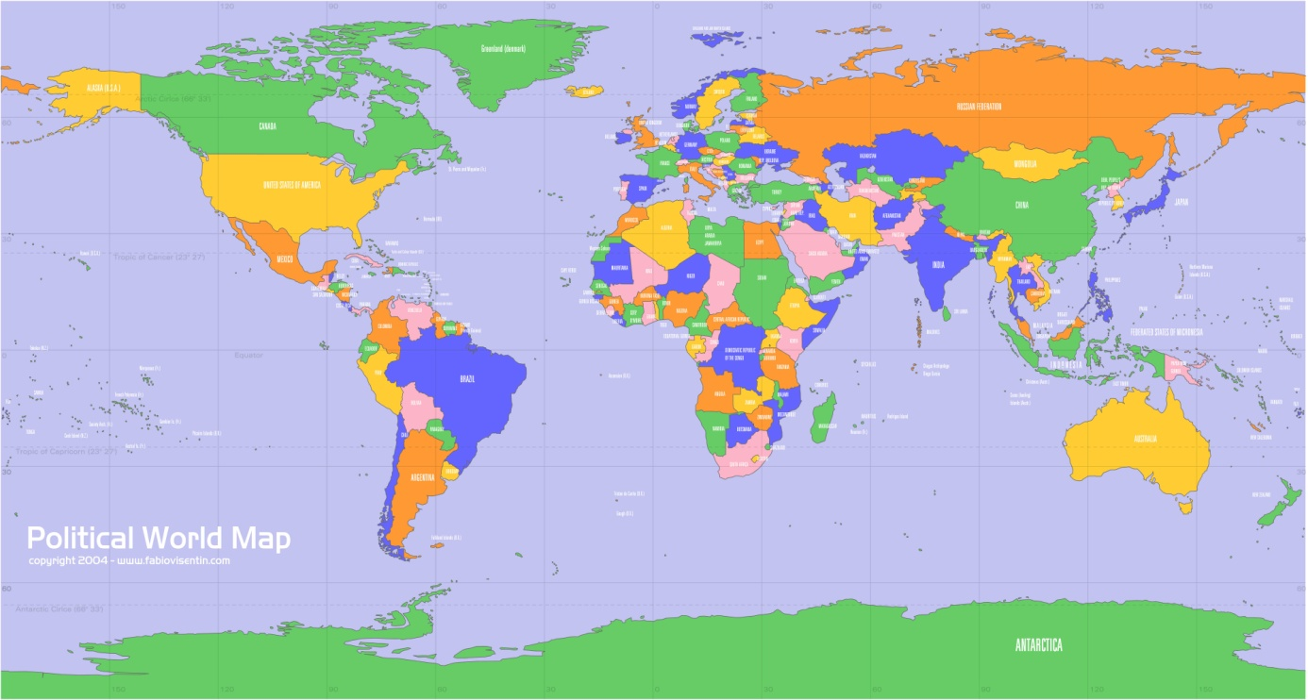

Worksheet 20: My house
Date:
Some people share their houses with other people, other people live all by themselves. With who do you live in your home? Write them down or try to draw them.

Worksheet 21: My friends
Date:
With who do you like to play the most? And what do you like to play with them? Write down or draw this.

Worksheet 22: Be alone
Date:
Some things are nice for sharing with other people. Maybe you like to play games or dance with others. Do you also want to be alone sometimes? Maybe you like to listen to music alone, just lay on your bed or maybe you can better concentrate on your homework when you are alone. Think about something that you rather do alone than accompanied by others and create your own door hanger.

Worksheet 23: Deserted island
Date:
Imagine an unknown island, far away, somewhere in the middle of the sea. If you are on that island and you were allowed to take three things (objects or people) with you. What or who would you take with you to the island? Draw your island and write down what you would take.

Worksheet 24: Puzzle your future
Date:
Have you ever thought about your future? Some people want to become a fireman, a policeman, an actress, a teacher or a singer. What do you dream of becoming when you are older? Draw the job of your dreams on a white paper. Glue it on a colored paper of your choice. Cut your drawing in different pieces (not to small!), so you can make a puzzle.

Worksheet 25: Fly away
Date:
Do you ever think of going to a country far away? Where would you go and why? Create your own boat or plane and write down where you would go with your own boat or plane.

Worksheet 26: I’ve got the music in me
Date:
Music is all around you. Think about the television, movies or think about some festivals in Nepal. If you could play any instrument you want, what instrument would you play? Try to draw or create your own instrument.

Worksheet 27: My idol is…
Date:
There are a lot of (famous) people in the world. You may have seen them in movies, clips or in magazines. If you could choose anyone to meet and everything is possible, who would you want to meet? And what would you like to ask them? Try to find a picture of this person in a magazine, news paper or ask a volunteer to find it for you on the internet. Or you can try to draw them.

Worksheet 28: Numbers
Date:
Do you have a lucky number? Try to draw your lucky number in an original way.

Worksheet 29: Kite in the air
Date:
Have you ever wanted to send a letter to someone you can’t reach? What if you could reach that person by using a kite? Create your own kite, write your letter and attach it to the kite.

Worksheet 30: Happy Holiday!
Date:
Divali, Tihar, Dashain, Christmas. There are lots of public holidays. Public holidays are not only celebrated in Nepal, but all over the world. What is your favorite holiday and why? Can you describe what this (public) holiday means for you?

Worksheet 31: Dinnertime!
Date:
Breakfast, lunch and dinner. Have you ever prepared a meal for family or friends? What is your favorite food and do you know how to prepare it? Write down the recipe or try to find how to make your favorite food.

Worksheet 32: It’s a joke
Date:
Knock, knock, who’s there? Do you know any of these or other jokes? Jokes are meant to make people laugh. What makes you laugh? Try to write it down.

Worksheet 33: The wizard
Date:
Imagine you are a wizard. And you have a magic wand. You can use the magic wand for anything you would like (to happen). What would you do with it? Create your own magic wand and write down (or draw) what you want to do with it.

Worksheet 34: I’m a teacher
Date:
You have to go to school every week. You walk into the classroom and the teacher prepared a lesson. What if you were the teacher? What would you do on a school day?

Worksheet 35: Fingerprints
Date:
Did you ever take a look at your fingers? Did you ever noticed the fine lines in your fingers? The fine lines in your skin is called your fingerprint. Every person had an unique fingerprint. Make your own fingerprint and describe what you think that makes you unique. A stamp pad is available in the closet.

Worksheet 36: Memory
Date:
Think of everything you are capable of, things you like to do and the people you love. Write down AND draw the following on small pieces of squared paper, so you can make memory out of it: three things you love to do, three things you are good at and three people you love. Place all the squared papers upside down and try to find the matching pieces (words and drawings).

Worksheet 37: Stop right now!
Date:
Traffic lights tell you when you can go on (green) or when you have to stop (red). These signs are very clear to all people. Sometimes it’s not very clear when you want people to stop or when other people want to stop you. For example, sometimes it’s fun to tease each other, but sometimes it’s not fun anymore and the teasing gets bullying. How do you stop other people and when do you want to stop them? Color the traffic light and write down when you want people to stop or go.

Worksheet 38: …
Date:

- Leukste leerkracht
- Hoe leven andere mensen in andere landen/ wat zijn de verschillen en/of overeenkomsten
- Ontwerp je eigen huis
- Papieren hoed vouwen
- Het leven door een andere bril bekijken/bril knutselen
- Eigen spelbord ontwerpen/ speelgoed ontwerpen
- Kwartet
- Favoriete kleur, een pagina in teken van die kleur
- Mooiste cadeau dat je ooit van iemand hebt gekregen
- Regenboog maken…
- Iets met de seizoenen
- Verbind de punten en kleur in (googlen)
- Pictureframe
- Magazine tekening afmaken
- Lievelingsnummer
- Poems
- Geloof / Waar geloof jij in?
- Dromenvanger maken (kan dat plat”?) enge en leuke dromen
- Varkenspaarpot: waar zou je voor sparen? Muntje overkrassen. Wat zou je met winnend lot doen?
- Doolhoven
- Collage maken

